Icosidodecahedron

Definition
# Source: AI Source: Provided by: [Data Path: Persons Table -> ID Column: 1, Name_En Column: Motasem Essam] -> From: [ChatGPT] on [7/25/2026]
An Icosidodecahedron is a convex Archimedean solid composed of 32 regular polygonal faces: 20 equilateral triangles and 12 regular pentagons.
It has 30 vertices and 60 edges. Every vertex is surrounded by four alternating faces: two equilateral triangles and two regular pentagons.
It is also known as a Pentagonal Gyrobirotunda.

Geometric Structure
# Source: AI Source: Provided by: [Data Path: Persons Table -> ID Column: 1, Name_En Column: Motasem Essam] -> From: [ChatGPT] on [7/25/2026]
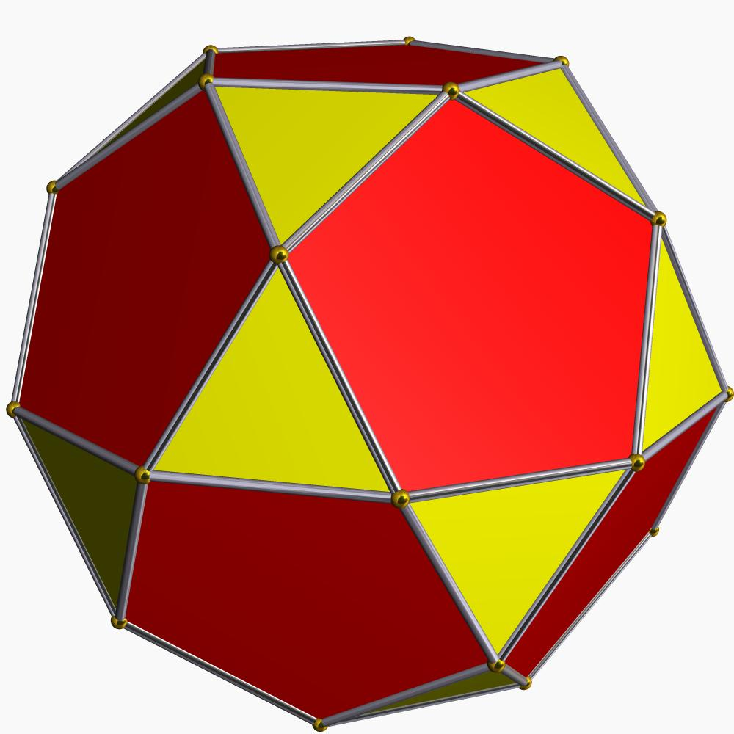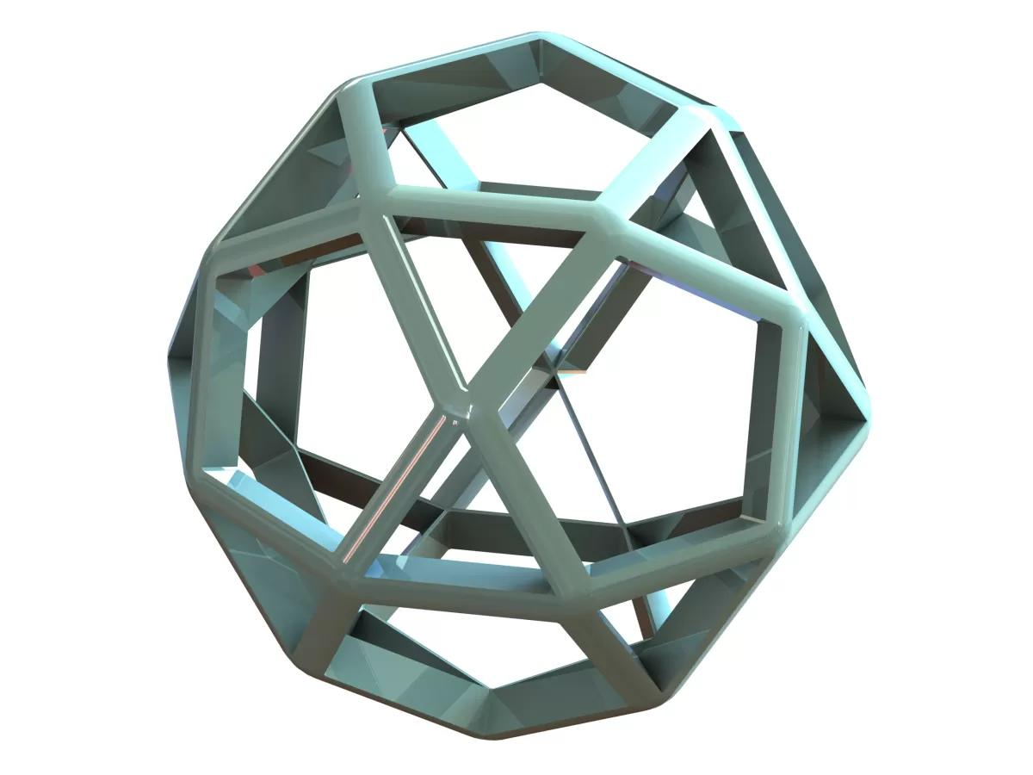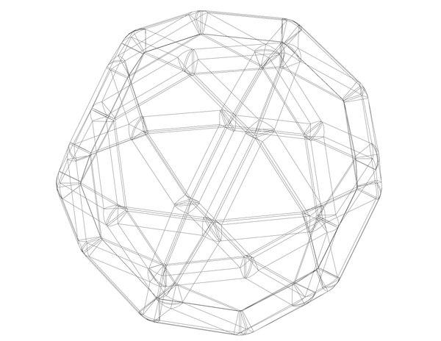
The solid consists of two types of regular polygonal faces:
- 20 Triangular Faces: Equilateral triangles.
- 12 Pentagonal Faces: Regular pentagons.
The triangular and pentagonal faces alternate around each vertex.

Face Composition
# Source: AI Source: Provided by: [Data Path: Persons Table -> ID Column: 1, Name_En Column: Motasem Essam] -> From: [ChatGPT] on [7/25/2026]

Face Type | Number | Shape
Triangular Faces | 20 | Equilateral triangle
Pentagonal Faces | 12 | Regular pentagon
Total Faces | 32 | —

Mathematical Properties
# Source: AI Source: Provided by: [Data Path: Persons Table -> ID Column: 1, Name_En Column: Motasem Essam] -> From: [ChatGPT] on [7/25/2026]
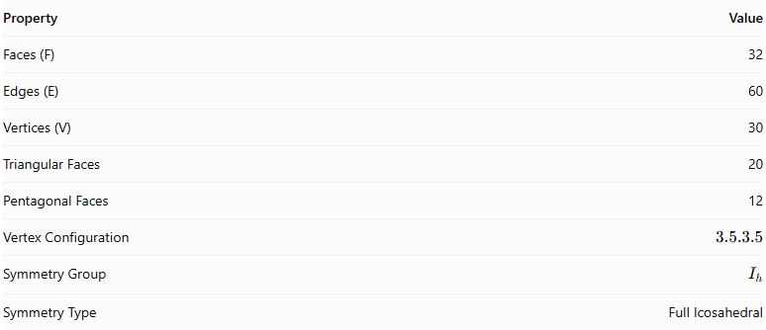
Property | Value
Faces (F) | 32
Edges (E) | 60
Vertices (V) | 30
Triangular Faces | 20
Pentagonal Faces | 12
Vertex Configuration | $$3.5.3.5$$
Symmetry Group | $$I_{h}$$
Symmetry Type | Full Icosahedral
Euler's Formula:
$$V-E+F=2$$
$$30-60+32=2$$
Surface Area:
For edge length $a$:
$$A=(5\sqrt{3}+3\sqrt{25+10\sqrt{5}})a^{2}$$
Volume:
$$V=\frac{45+17\sqrt{5}}{6}a^{3}$$
These formulas apply to the regular Icosidodecahedron with equal edge lengths.

Geometric Characteristics
# Source: AI Source: Provided by: [Data Path: Persons Table -> ID Column: 1, Name_En Column: Motasem Essam] -> From: [ChatGPT] on [7/25/2026]
- It is a convex Archimedean solid.
- It is one of the two convex quasiregular polyhedra, along with the Cuboctahedron.
- All faces are regular polygons.
- All edges have equal length.
- Every vertex has the same arrangement of faces.
- Its vertex configuration is $3.5.3.5$, meaning that triangles and pentagons alternate around each vertex.
- It has full icosahedral symmetry, represented by $I_{h}$.
- Its dual polyhedron is the Rhombic Triacontahedron.

Geometric Construction
# Source: AI Source: Provided by: [Data Path: Persons Table -> ID Column: 1, Name_En Column: Motasem Essam] -> From: [ChatGPT] on [7/25/2026]
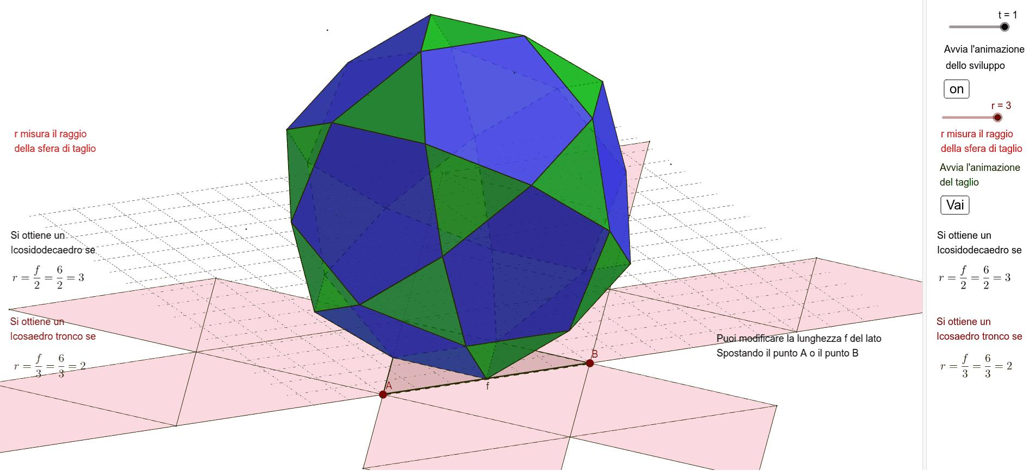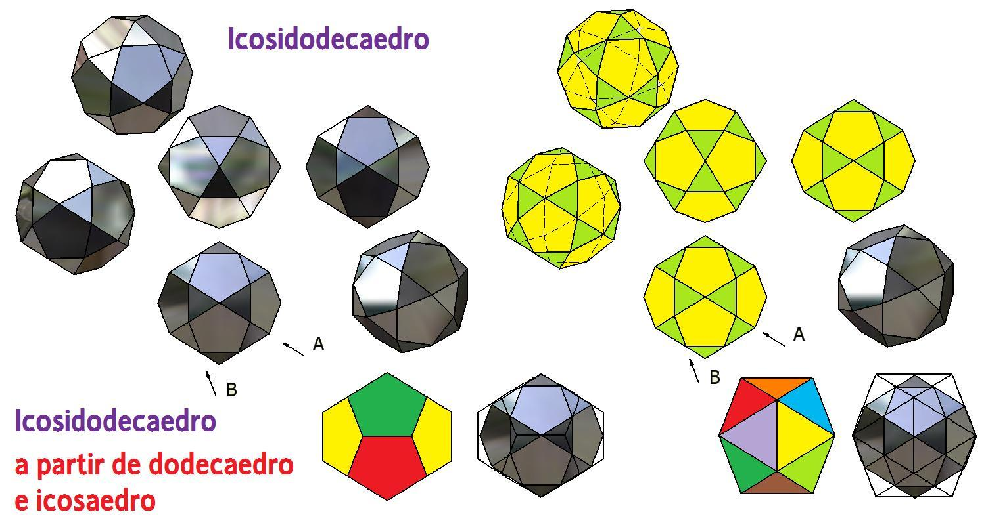
The Icosidodecahedron can be constructed by rectifying an Icosahedron or a Dodecahedron.
- Begin with an Icosahedron or Dodecahedron.
- Locate the midpoint of every edge.
- Use these edge midpoints as the vertices of the new solid.
- Connect the midpoints according to the original faces and vertices.
- The original triangular faces produce 20 equilateral triangles, while the original pentagonal faces produce 12 regular pentagons.
The resulting solid has 30 vertices, 60 edges, and 32 faces.

Related Geometric Solids
# Source: AI Source: Provided by: [Data Path: Persons Table -> ID Column: 1, Name_En Column: Motasem Essam] -> From: [ChatGPT] on [7/25/2026]
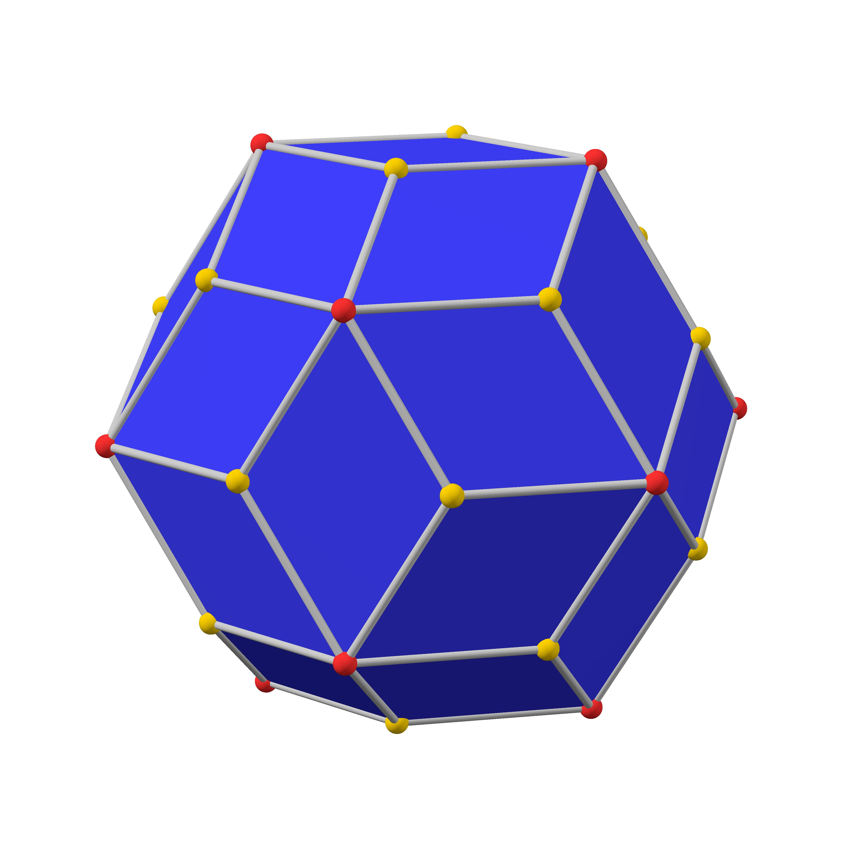
Rhombic Triacontahedron
The dual polyhedron of the Icosidodecahedron, consisting of 30 rhombic faces.
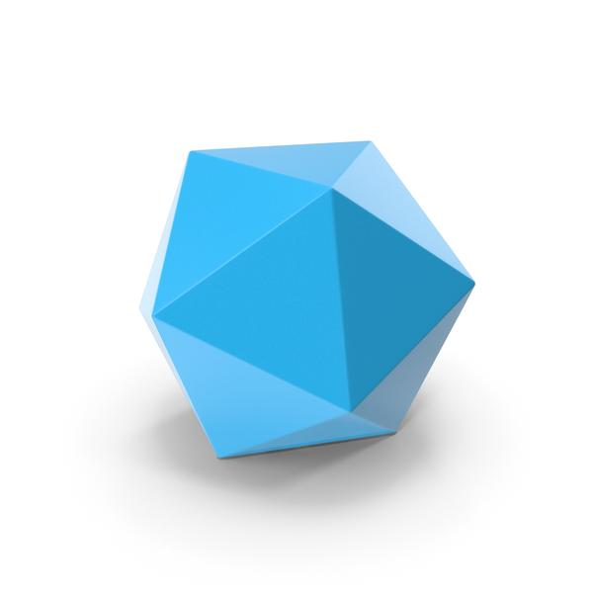
Icosahedron
A Platonic solid with 20 equilateral triangular faces. Rectifying it produces an Icosidodecahedron.
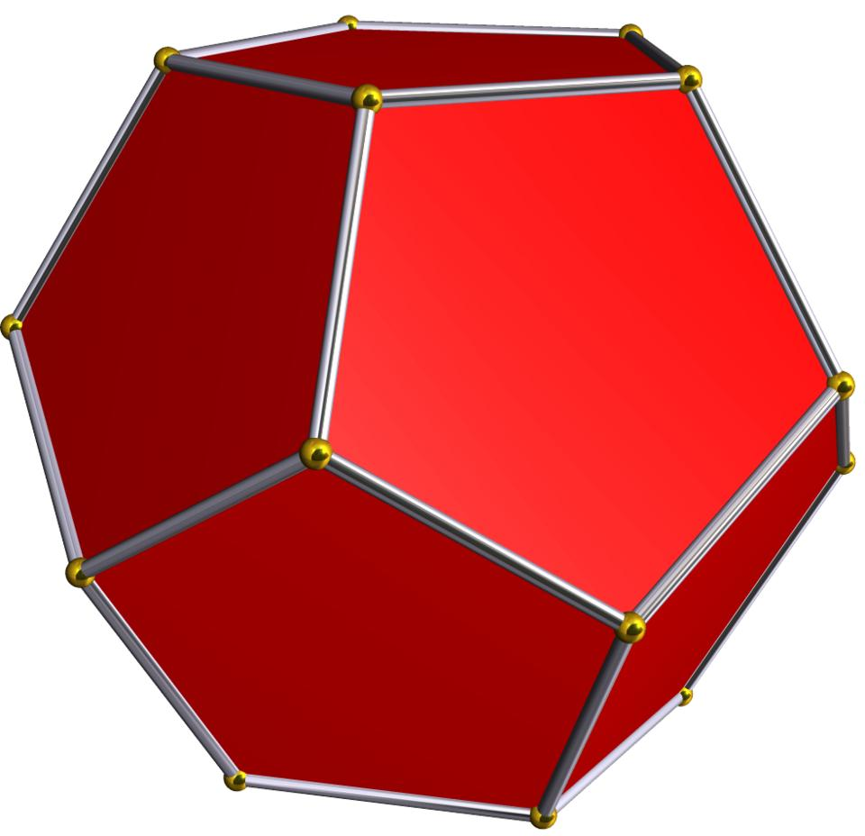
Dodecahedron
A Platonic solid with 12 regular pentagonal faces. It can also be rectified to produce an Icosidodecahedron.

Key Points
# Source: AI Source: Provided by: [Data Path: Persons Table -> ID Column: 1, Name_En Column: Motasem Essam] -> From: [ChatGPT] on [7/25/2026]
- The Icosidodecahedron is one of the 13 classical Archimedean solids.
- It has 32 faces, 60 edges, and 30 vertices.
- Its faces consist of 20 equilateral triangles and 12 regular pentagons.
- Its vertex configuration is $3.5.3.5$.
- It has full icosahedral symmetry $I_{h}$.
- It can be constructed by rectifying an Icosahedron or Dodecahedron.
- Its dual is the Rhombic Triacontahedron.
- It is also known as the Pentagonal Gyrobirotunda.

Main Classification
# Source: AI Source: Provided by: [Data Path: Persons Table -> ID Column: 1, Name_En Column: Motasem Essam] -> From: [ChatGPT] on [7/25/2026]
Solid Geometry
└── Types of Solids
└── Icosidodecahedron
├── Triangular Faces
├── Pentagonal Faces
├── Vertices
├── Edges
└── Geometric Properties

Conclusion
# Source: AI Source: Provided by: [Data Path: Persons Table -> ID Column: 1, Name_En Column: Motasem Essam] -> From: [ChatGPT] on [7/25/2026]
The Icosidodecahedron is a convex Archimedean solid distinguished by its alternating triangular and pentagonal faces. Its quasiregular structure, icosahedral symmetry, and relationship to the Icosahedron, Dodecahedron, and Rhombic Triacontahedron make it an important polyhedron in solid geometry.

